Project Design Phase
System Architecture
Date | 12 July 2026
Team ID | SWTID-2026-4644
Project Name | Smart Lender
Phase | 3. Project Design Phase

Purpose
While Solution_Architecture.docx shows the logical flow of a single request, this System Architecture document shows the physical/infrastructure tiers involved in running Smart Lender, distinguishing what exists today from what is proposed for production deployment.

System Architecture Diagram
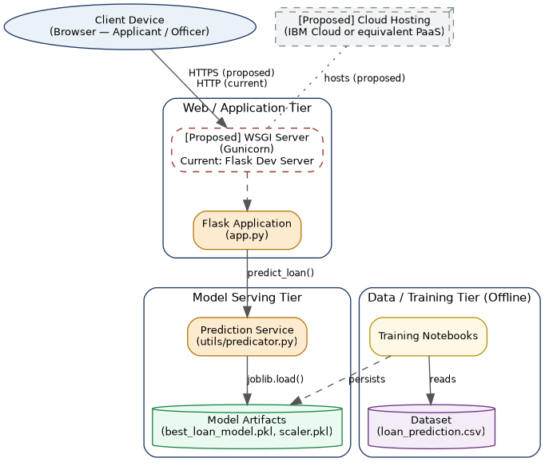

Figure 1: System Architecture — Web/Application, Model Serving, and Data/Training tiers.

Tier Descriptions
Tier | Current State | Proposed State
Client | Browser (any device with network access to the Flask server) | No change — remains a standard web browser
Web / Application | Flask's built-in development server, single-threaded | [Proposed] Gunicorn (or similar) WSGI server with multiple workers, behind HTTPS
Model Serving | In-process: model and scaler loaded via joblib inside the Flask process | Same approach retained — no external model-serving API needed at this scale
Data / Training | Local CSV dataset + local notebooks, run manually and outputs committed to disk | [Proposed] Scheduled retraining pipeline with versioned model artifacts
Hosting | Local machine / container (as used for this documentation's live testing) | [Proposed] Managed cloud platform (e.g., IBM Cloud) for public accessibility

Deployment Topology Notes
- The current system has no load balancer, no database, and no separate model-serving microservice — it is intentionally a single-process MVP.
- The proposed WSGI/cloud tier changes do not require changing the application code — utils/predicator.py's load-once pattern is already compatible with multiple worker processes.
- No caching layer exists or is currently needed, since inference is already sub-10ms once warm (see Performance_Testing.docx).

